**Pie Chart**

Strategy 1:-

Input dataset for subsequent claims:

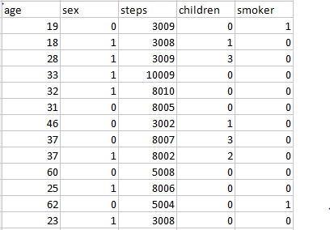

This dataset contains 8 fields and 98 records. The following fields are age,sex,steps,children,smoker and etc.

Output for subsequent claims:

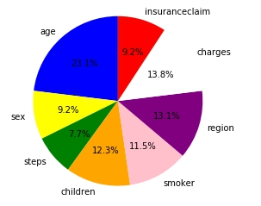

By using the above dataset we have generated the pie chart

Strategy 2:-

Input dataset for policy cancellation:

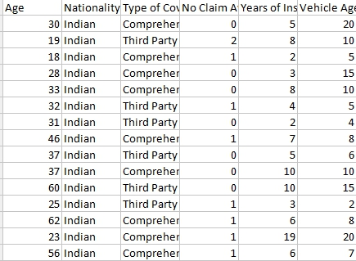

This dataset consists of 11 fields and 29 records.The following fields are age,nationality,type of coverage,no claim availed,year of insurance undertaking and etc.

Output dataset for policy cancellation:

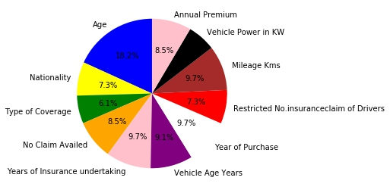

Strategy 3:-

Input dataset for Theft:

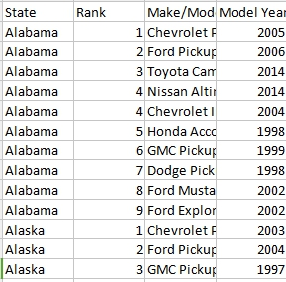

This dataset consists of 5 fields and 511records.The following fields are State,Rank,Make/Models,Model Year and etc.

Output dataset for policy cancellation:

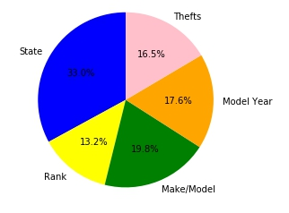

**Visualization:**

Strategy 1:-

Input dataset for subsequent claims:



This dataset contains 8 fields and 98 records. The following fields are age,sex,steps,children,smoker and etc.

Output for subsequent claims:

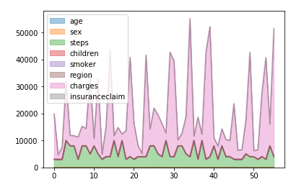

Strategy 2:-

Input dataset for policy cancellation:



This dataset consists of 11 fields and 29 records. The following fields are age,nationality,type of coverage,no claim availed,year of insurance undertaking and etc.

Output dataset for policy cancellation:

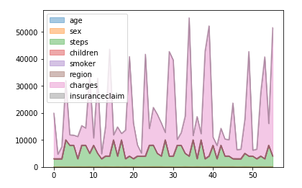

Strategy 3:-

Input dataset for Theft:



This dataset consists of 5 fields and 511records.The following fields are State,Rank,Make/Models,Model Year and etc.

Output dataset for theft:

